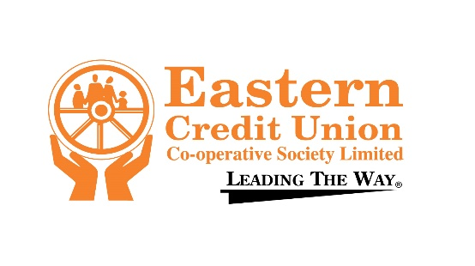
PRIMARY SCHOOLS
CALYPSO COMPETITION 2024

PRELIMS - 25th January 2024 9:00 am - 12:00 pm
FINALS – 1st February 2024 9:00 am - 1:00 pm
PLEASE COMPLETE IN BLOCK LETTERS
Name of Singer / Participant: ………………………………………………………………………………………………...................
SCHOOL: ………………………………………………………………………. Contact #: ………………………………………………..
AGE: ………………… MEMBER NO. ………………………………………………………………….
SONG TITLE: …………………………………………………………………………………………………………………………………………..
Backup SINGERS: ………………………………………………………………………………………………………………………………
……………………………………….……………………………………………………………………………………..
…………………………………………………..………………………………………………………………………….
……………………………………………….……….…………………………………………………………………….
Teacher (s):…………………………………………………………………….……………………………………………………………………….
Name of Principal: …………………………………………………………………………………………………………………………………
PARENT/ GUARDIAN: ……………………………………………………………………………………………………………………………
CELL NUMBER: ………………………………………… HOME NUMBER: ………………………………………………….…….
DATE: ……………………………………………………. SIGNATURE: ……………………………………………………………….

ALL finalists MUST provide INSTRUMENTAL AUDIO/ CD (NO VOCALS)
Deadline date for registration form SUBMISSION: FRIDAY 19TH JANUARY, 2024.
Email completed forms to: ksalandy@easterncutt.com and lrogers@easterncutt.com

